Geospatially Resolved CCS and Hydrogen Deployment in China Reveals 7.5 GtCO₂ Storage by 2050

Spatially Explicit Assessment of CCS and Hydrogen Infrastructure in China Enables 7.5 GtCO₂ Storage by 2050

Caroline Acen¹, Olusola Bamisile*^{1,2,3}, Daniel O. Olasehinde¹, Omosalewa O. Olagundoye¹, Chukwuebuka J. Ejiyi¹, Qi Huang¹, Iain Staffell*²
¹ Sichuan Industrial Intelligent Monitoring and Application Engineering Technology Research Centre, College of Nuclear Science and Automation Engineering, Chengdu University of Technology, Sichuan, 610059, P.R. China.
² Centre for Environmental Policy, Faculty of Natural Science, Imperial College London, United Kingdom.
³ Energy and Environmental Science Division, CEPMLP, University of Dundee, Scotland, United Kingdom.
*Corresponding author: obamisile001@dundee.ac.uk, i.staffell@imperial.ac.uk

Abstract
Climate mitigation scenarios rely on large-scale deployment of carbon capture and storage (CCS) to achieve net-zero emissions, particularly for hard-to-abate sectors. China, the world’s largest emitter, has ample rock formations that could store CO₂, yet their usable capacity, cost and safety remain poorly known, with no detailed assessment of how fast, cheap and safe CCS could be rolled out across China’s heavy industries. Here, we present a national-scale, spatially resolved assessment of CCS deployment potential in China, using a 5×5 km resolution geospatial dataset of storage capacity and injection rate constraints for deep saline aquifers and enhanced oil recovery targets. Our approach quantifies realistic rate-constrained CO₂ removal costs, optimizing the spatial matching of emission sources and blue hydrogen facility siting with geological sinks. We analyse provincial-level contributions to emissions reduction, and geo-mechanical risk. This framework combines techno-economic modelling with geospatial information system overlays and proximity-based ranking. We find China's lowest full-chain CCS cost of 848,000 USD/km in 2025 declines to 15,000 USD/km by 2050 for pipeline transport projects due to economies of scale and technological maturation. Pipelines are cheaper than tanker-based transport, with 14% average cost reduction in 2025 and 29% by 2050. China’s technical sequestration potential could reach 1260 MtCO₂ by 2030 and 7510 MtCO₂ by 2050 for aquifers, compared to 1080 and 820 MtCO₂ for oil recovery. By developing storage potential into a risk-aware development pathway, this work links China’s 2060 carbon-neutrality pledge to an infrastructure strategy that can inform other major emitters.

Keywords
Carbon Capture and Storage (CCS), Techno-economic Analysis, Marginal Abatement Cost, Geospatial Analysis, Blue Hydrogen, Proximity Analysis, Source-sink matching.

Main
The long-held target of limiting global warming below 1.5°C without overshoot looks increasingly unrealistic. Global greenhouse gas (GHG) emissions must fall by around 55% by 2035 to follow such a pathway ^{1,2}, reaching net-zero by 2050 ³. In this transition, carbon capture utilization and storage (CCUS) is widely thought of as a valuable solution to emissions across many hard-to-abate sectors like aviation, shipping, trucking, steel, cement, aluminium, chemicals, and oil and gas production. These sectors contributed ~40% of global greenhouse gas (GHG) emissions in 2024, and are seeing slower progress than electricity generation and light transport ^{4,5}.
Current climate mitigation scenarios consistently attribute a critical and substantial role to Carbon Capture, Utilization, and Storage (CCUS). To achieve global net-zero emissions by 2050, CCUS must scale dramatically, from capturing around 1-5 GtCO₂ per year in 2030 to approximately 5-13 GtCO₂ annually by 2050 ^{3,6}. This would represent about 8% of the energy sector emissions reduction ³ and 15% of the cumulative emission reductions required by half-century ⁷. While current deployment is nascent, with about 50 facilities operating globally, capturing 51 MtCO₂ per year, with 44 projects under construction and 480-534 projects in the planning stage ^{8,9}. If all proposed projects are completed, global capacity could reach over 500 MtCO₂ annually ¹⁰, representing 0.9-1.1% of current global GHG emissions ¹¹.
Projections from the IEA Sustainable Development Scenario ⁷ indicate that CCUS could contribute nearly 15% of cumulative emission reductions. ⁴IEA net-zero roadmap estimates that CCUS must mitigate 8% of energy sector emissions to achieve carbon neutrality by 2050, scaling from 1 GtCO₂ annually by 2030 to 5 GtCO₂ by 2050 ³. IPCC scenario analyses present a broad spectrum of potential CCUS deployment outcomes, suggesting that CCUS could reduce emissions by 0-5 GtCO₂ by 2030 (median estimate: 1 GtCO₂), expanding to 0-13 GtCO₂ by 2050 (median estimate: 2-3 GtCO₂) when applied to fossil fuel systems. Accelerating net-zero timelines from 2070 to 2050 would require a 50% increase in CCUS deployment ⁴. These projections suggest CCUS could contribute ~6% of the total mitigation required to reach net-zero emissions by mid-century ². Current deployment statistics from the Global CCS Institute and IEA reveal 50-53 operational CCUS facilities worldwide, with a combined capture capacity of 51 MtCO₂ annually. About 44 projects are under construction with similar capacity, while 480-534 projects remain in planning stages ^{8,9}. If all proposed projects reach completion, total global CCUS capacity could reach 416-520 MtCO₂ annually [9], representing 0.9-1.1% of current global GHG emissions ¹¹. Existing literature confirms that the theoretical geological capacity for CO₂ storage is vast. A risk-based planetary assessment by Gidden et al. suggests a prudent global storage limit of approximately 1,460 GtCO₂, with around 70% occurring onshore and 30% offshore ¹². Similarly, national analyses, such as one focused on China by Zhong et al., indicate that onshore basins alone could store 448 GtCO₂, enough to permanently sequester the country's cumulative emissions from 1990 to 2060 ¹³.China is the world’s largest GHG emitter, producing 29% of global CO₂ emissions in 2024 ¹⁴. The nation has committed to achieving carbon neutrality by 2060, with peak emissions by 2030 ^{15,16}. Given China’s dominant role in coal consumption (4.9 Gt in 2024) ¹⁷ and production (4.76 Gt) ¹⁸,¹⁷ CCUS will be critical for decarbonizing hard-to-abate sectors while balancing energy security and economic growth ¹⁹. Currently, China hosts 36 CCUS projects ^{8,9}, of which 64% are operational, 14% in planning, and 22% under construction ⁹. While current project capture capacity remains limited to approximately 1 MtCO₂ annually, coal-based projects are prioritized, with projected post-2030 capture potential reaching 40–43 MtCO₂ and CCS capacity reaching 3 MtCO₂/year by 2030 ^{8,9}. Initially driven by industrial CO₂ utilization in food processing and manufacturing sectors, China’s CCUS development is now motivated by climate objectives. To align with a viable carbon neutrality pathway by 2060, China must expand its annual CCUS capacity to 200 MtCO₂ by 2030 and 2.7 GtCO₂ by 2050 ¹⁹.
While current research has made significant progress in estimating CO₂ storage capacity, several limitations persist. Five limitations undermine their practical utility and risk misinforming investment and policy decisions. Firstly, current CCS deployment planning frequently omits geological storage potential coupled with injection rate constraints ²⁰. This fails to capture the link between storage volume and the rate at which CO₂ can be safely sequestered, which is a primary determinant of a site’s practical value and cost. Secondly, it provides insufficient consideration of risk assessment for geological containment. The potential for CO₂ leakage through undetected or reactivated faults, or the triggering of induced seismicity due to prolonged fluid injection ^{21,22}, poses significant environmental and social acceptance challenges that are frequently addressed qualitatively, if at all, rather than through integrated, quantitative geospatial analysis ^{23,24}. Thirdly, long-term effects of extreme events, socio-economic change, and spatial heterogeneity in source–sink distribution are neglected in current analyses ^{25,26}. The significant distances between major industrial emitters and optimal storage basins create substantial economic and logistical barriers that are glossed over in national-scale aggregate analyses (see Supplementary Note 1). Fourthly, most analyses prioritize a limited number of hard-to-abate sectors (power, iron and steel, chemicals, cement), thereby neglecting the essential role of other industries in meeting climate goals ^{27,28}. Fifthly, most studies do not fully account for secondary CO₂ transport modes within individual emission hubs or the potential evolution of CCUS infrastructure layouts over time ²⁹.
These knowledge gaps highlight the need for more comprehensive CCS planning frameworks that move beyond siloed assessment to integrate geological capacity, injectivity dynamics, geomechanical risks, and socio-technical constraints into a unified model for strategic investment and policy formulation.
Here, we present a modelling framework that combines techno-economic modelling, geospatial assessment, source-sink matching, and proximity analysis. We use China’s high-resolution grid-level datasets (see Methods), for several applications: quantifying investment costs for CO₂ sequestration at potential storage sites through spatial mapping; establishing optimal coupling between emission sources (industrial clusters) and storage sinks using fine-grid resolution analysis; assessing provincial-level contributions of CCS to emission reduction; identifying suitable locations for blue hydrogen facility development co-located with CO₂ storage reservoirs; and evaluating geological storage risks through analysis of active fault lines to determine areas with higher potential for CO₂ leakage or induced seismicity. Although China possesses substantial CO₂ storage capacity, its practical deployment faces significant challenges due to the heterogeneous spatial distribution of storage resources, injectivity limitations, and considerable distances between suitable storage sites and major emission sources (see Supplementary Note 2). Our work provides a high-resolution (5×5 km) spatial and economic evaluation of China’s CCS potential, linking fundamental geological assessments and implementable decarbonization pathways.

Estimating the Carbon Removal Cost Curve
Here, we calculate the full-chain CCS costs across 12 distinct scenarios with minimum, average, and maximum unit cost estimates for capture, transport, and storage/injection phases. These scenarios consider both pipeline and tanker transportation modes for enhanced oil recovery (EOR) and deep saline aquifer (DSA) storage options (see Methods; Supplementary Table 1–4). Our analysis reveals that pipeline transport represents a more cost-effective solution for CCS compared to tanker-based systems within a 250 km radius of storage sinks (Supplementary Figure 2–13). Figure 1 and Figure 2 illustrate the spatial distribution of average full-chain CCS costs at 5×5 km resolution across all scenarios, demonstrating how geological storage potential and injectivity constraints influence CCS economics throughout China from 2025 to 2050.
The full-chain CCS cost across China exhibits spatial and temporal heterogeneity. In 2025 (Figure 1(a)), costs are notably higher in several regions, especially in parts of the northwest, northeast, and south-eastern coastal areas, where they exceed 4.5 million USD/km. Conversely, the lowest-cost areas are dispersed across central, north-central, and north-eastern China. By 2030 (Figure 1(b)) and 2035 (Figure 1(c)), a substantial reduction in costs is observed across numerous regions because of technological advancements, infrastructure maturation, and achieved economies of scale. Concurrently, a significant expansion of red-shaded zones, particularly throughout northern and eastern China, signals the progressive exhaustion of accessible storage capacity in these regions. This trajectory persists through 2040–2050 (Figure 1(d)-(f)), as the saturation of optimal storage sites forces operations to shift toward locations with higher marginal costs. The minimum full-chain costs for DSA are 838 in 2025, 727 by 2030, and 347 by 2050 USD/km (see Supplementary Table 1 and 2).
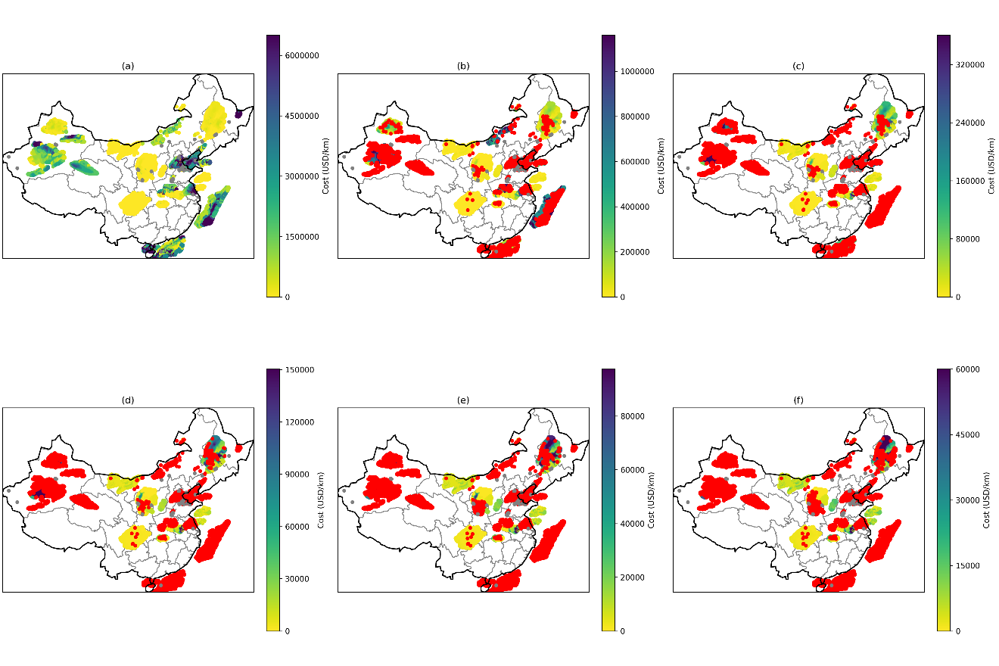
Figure 1: The average carbon sequestration cost for both DSA and EOR using pipeline transport for (a) 2025, (b) 2030, (c) 2035, (d) 2040, (e) 2045, and (f) 2050. The grey-shaded regions represent areas where storage potential remains untapped due to undetermined injection rates at those specific grid points, while the red-shaded areas indicate areas where the storage potential has been exhausted/fully utilized.

While the spatial cost patterns of tankers (Figure 2) are similar to those for pipelines (Figure 1), tanker costs are systematically higher, a difference that is most pronounced in the initial years (2025-2035) (Supplementary Table 2 and 4).
The minimum costs for EOR are 518 in 2025, 1540 by 2030, and 736 by 2050 USD/km (see Supplementary Table 3 and 4). Due to increased per-unit costs and logistical constraints associated with tanker-based CO₂ transport (Supplementary Figures 8 and 9), pipeline transport proves more economical, yielding an average cost reduction of 14% relative to tanker transport across all grid points for DSA in 2025. This cost advantage increases to 16% in 2030 and 29% by 2050. For EOR, the corresponding reductions are 14% (2025), 19% (2030) and 29% (2050). These results highlight the economic importance of prioritizing pipeline infrastructure for long-term, scalable CCS deployment, especially in regions possessing high injection rates and substantial storage potential. The expansion of red-shaded regions, indicating exhausted storage capacity, occurs more rapidly in EOR scenarios than in DSA across all modelled scenarios (Supplementary Figure 2–13). This trend reflects the more limited distribution and lower overall storage potential of EOR sites compared to the extensive and capacious DSA (Supplementary Figure 1).
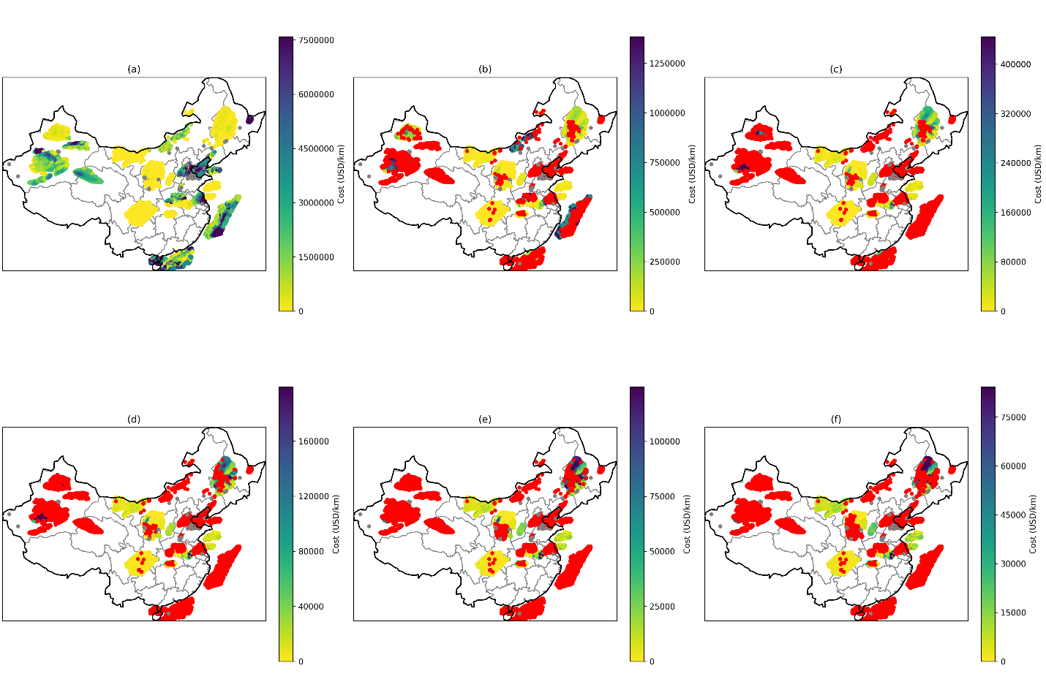
Figure 2: The average carbon sequestration cost for both DSA and EOR using tank transport for (a) 2025, (b) 2030, (c) 2035, (d) 2040, (e) 2045, and (f) 2050. The colour scheme is the same as explained in Figure 1.
Analysis across all scenarios reveals that the most favourable regions can sequester approximately 18, 8, and 4 MtCO₂ at a 5th percentile cost of 2346 (2025), 1754 (2030), and 303 (2050) USD/km, respectively (Supplementary Figure 2–13). Similarly, the 10th percentile costs are 3048 (2025), 2198 (2030), and 832 (2050) USD/km, facilitating the sequestration of 52, 26, and 10 Mt of CO₂, respectively (Supplementary Table 1–4).

Risk Assessment of CO₂ Storage Leakage
Active fault lines and associated seismicity present substantial risks to the security of geological CO₂ storage. The injection of CO₂ into subsurface formations elevates pore pressure, which can induce earthquakes ³⁰, as seismic activity can create new fractures or reactivate existing faults and caprock seals. This provides pathways for the stored CO₂ to migrate out of the deep reservoir and potentially reach the surface or contaminate freshwater aquifers ³¹, warranting detailed site-specific geotechnical evaluation before project deployment. Consequently, a thorough spatial analysis of the relationship between fault networks and prospective CO₂ storage reservoirs is essential for robust risk assessment and the selection of secure sequestration sites. Spatial analysis of geological CO₂ storage sites in China reveals significant heterogeneity in associated risk factors (Figure 3(a)). Areas with very high-risk factors (8–10) are located in some parts of eastern and south-eastern coastal areas, coinciding with the identified DSA storage formations. This higher risk correlates directly with proximity to active tectonic faults and a historical frequency of seismic events (see Methods, Supplementary Figure 14 and Supplementary Figure 15), making stringent monitoring and proactive pressure management strategies advisable in these tectonically complex areas. Moderate to high risk (3–8) is observed across large parts of northern, eastern, and coastal regions of China, reflecting moderate seismic hazard influenced by regional faults and localized site amplification. In contrast, lower-risk sites (below 3) are primarily situated within north-western and central regions, such as Xinjiang and the Sichuan basin. The relationship between storage potential and risk is further depicted in Figure 3(b), which illustrates a general trade-off wherein sites with higher storage capacity typically exhibit higher risk factors, forming a major diagonal cluster. However, a cohort of sites, exclusively DSAs located in the lower-right quadrant, deviates from this trend by offering high storage capacity (>200 MtCO₂) alongside a comparatively low risk (<2), identifying them as priority candidates for future storage projects. This geospatial analysis shows the importance of integrating fault and seismic risk data into site selection processes, identifying areas where CCS deployment would necessitate additional monitoring and mitigation strategies to ensure safe, reliable, and long-term containment.
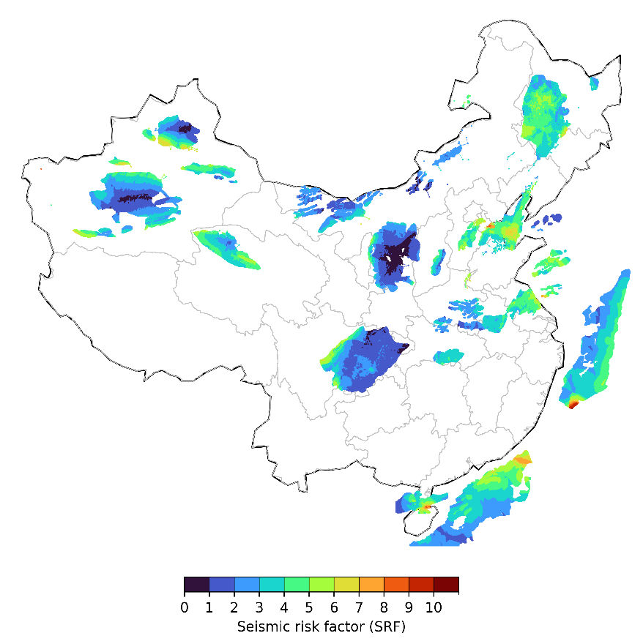
(a)
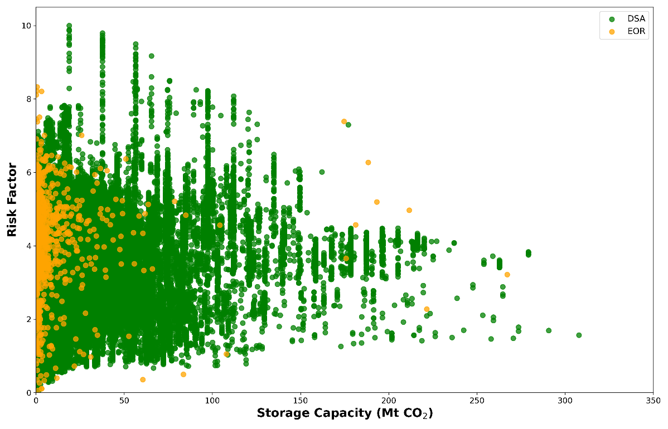
(b)
Figure 3: (a) Seismic risk factor spatial distribution and (b) risk factor at the DSA and EOR storage capacity. The spatial heterogeneity of the risk factor is depicted using a graduated colour scheme, where lighter shades denote lower-risk areas, representing the most suitable sites for geological CO₂ storage.
The sensitivity analysis in Supplementary Figure 17 demonstrates that the seismic risk factor is highly responsive to changes in the seismic hazard level, as defined by different Peak Ground Acceleration (PGA) exceedance probabilities. Compared to the base case (10% probability in 50 years), the seismic risk factor does not remain constant but shows a systematic increase across some sites, with the magnitude of increase directly tied to the severity of the hazard scenario. The amplification risk increases up to 44% for the 1% probability level and by 34% for the 0.5% probability level, particularly accentuating risk in already high-hazard zones. Conversely, the most common shaking scenario (63% probability in 50 years) results in the smallest changes, with risk factors increasing up to 14%, indicating a more uniform, lower-risk landscape. The risk factor increases up to 25% and 15%, for the 2% and 5% probability exceedance level. However, in localized regions, the risk factor can also decrease, with reductions of up to 38%, 131%, 16%, 7%, and 94% observed for the 0.5%, 1%, 2%, 5%, and 63% probability levels, respectively. This systematic escalation confirms that the choice of hazard exceedance probability directly and substantially influences the final risk ranking, with the largest relative increase occurring for the lowest-probability (highest-intensity) scenarios, particularly in regions of already elevated seismic hazard.

Supplementary Figure 18 reveals that the calculated seismic risk factor is significantly influenced by the methodological choice for estimating site amplification vulnerability, demonstrating that risk does not remain the same as the base case when this component is varied. Compared to the base case, which used the Boore et al. ³² empirical model, the application of both the GB 50011-2010 code method ³³ and the assumption of no amplification results in risk factor increases of up to 100% across the storage site locations. The spatial pattern and approximate magnitude of increase are notably similar for both alternative methods, indicating a consistent directional shift in risk assessment when deviating from the empirically derived amplification model. This sensitivity highlights the site response component as a major source of epistemic uncertainty in the risk framework, where conservative code-based classifications or the omission of amplification can substantially elevate the perceived risk, particularly at sites underlain by soft soils that are assigned higher vulnerability scores.
Supplementary Figure 19 demonstrates that the seismic risk factor is highly sensitive to the choice of the fault influence decay constant (λ), with both the magnitude and spatial pattern of risk changing substantially from the base case (λ = 200 km). Compared to the base case, the risk factor decreases by up to 100% for λ = 50 km, up to 61% for λ = 100 km, up to 38% for λ = 300 km, and up to 89% for λ = 500 km. Conversely, in other areas, the risk factor increases by up to 280% for λ = 50 km, 37% for λ = 100 km, 46% for λ = 300 km, and 99% for λ = 500 km. Conversely, in other areas, the risk factor increases by up to 280% for λ = 50 km, 37% for λ = 100 km, 46% for λ = 300 km, and 99% for λ = 500 km. This bipolar response highlights that the fault proximity model's spatial influence is not uniform; a smaller λ sharply localizes risk to the immediate fault zones, drastically reducing risk elsewhere but massively amplifying it for sites very near faults, while a larger λ spreads the fault influence more diffusely, moderating extreme local highs but elevating risk over broader regions farther from the fault traces.

Integrating CO₂ storage Sinks with Industrial Clusters
Effective CO₂ source-sink matching is a foundational step for deploying CCUS clusters and for designing associated pipeline networks, aiming to minimize transport costs and maximize carbon sequestration ²⁵. Figure 4(a) presents the spatial distribution of manufacturing industries (CO₂ sources) and geological storage sinks at high resolution. Industrial activity is heavily concentrated in the eastern, central, and southern regions, which benefit from proximity to both DSA and EOR storage resources, creating substantial potential for source-sink integration. Most industrial sources lie within 250 km of a viable storage site, delineating optimal zones for pipeline infrastructure that would reduce both economic and environmental costs. Priority for CCUS deployment is given to the MC industrial category (Supplementary Figure 20), a hard-to-abate sector facing significant barriers to electrification or renewable-based decarbonization, which contributes 31% of China’s current total emissions ³⁴. With China’s total geological CO₂ storage potential estimated at over 1,000 Gt and an average annual injection rate of 550 MtCO₂/year, the national capacity is sufficient for the strategic decarbonization of priority sectors, particularly if initial efforts are concentrated in regions with high source-sink proximity. The eastern and south-eastern regions present optimal conditions for integrated CCUS networks, hosting dense industrial clusters near geological storage. The spatial co-location of multiple industrial types in these areas improves the economic viability through shared infrastructure and economies of scale.
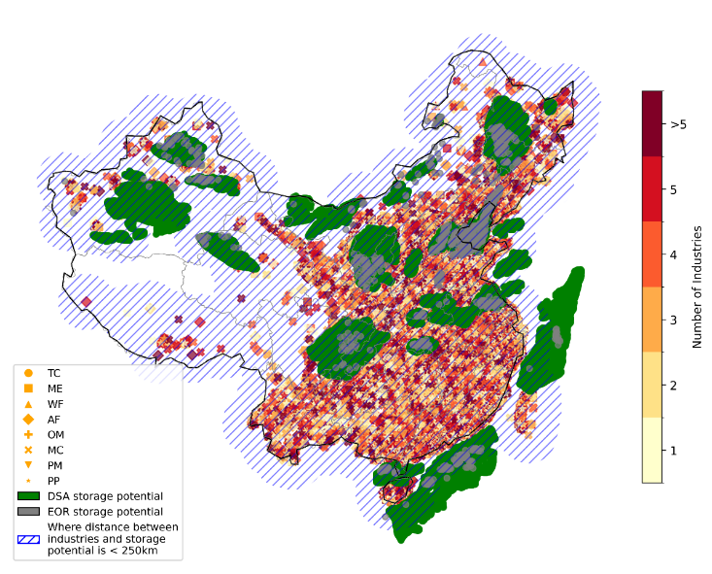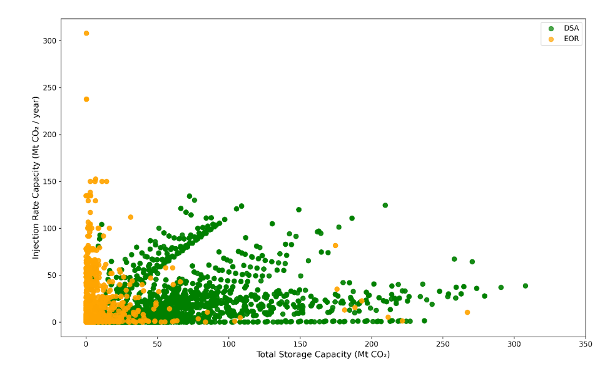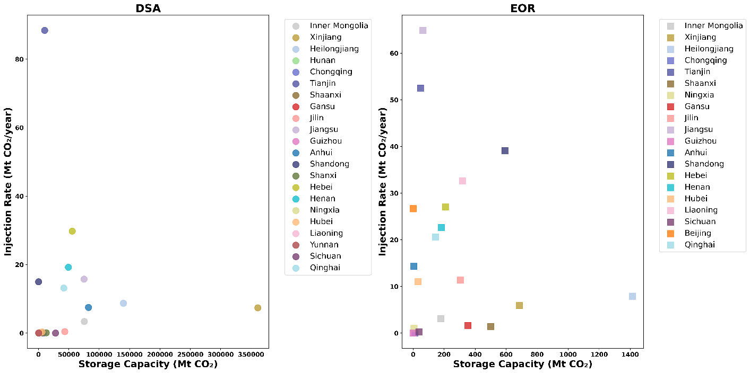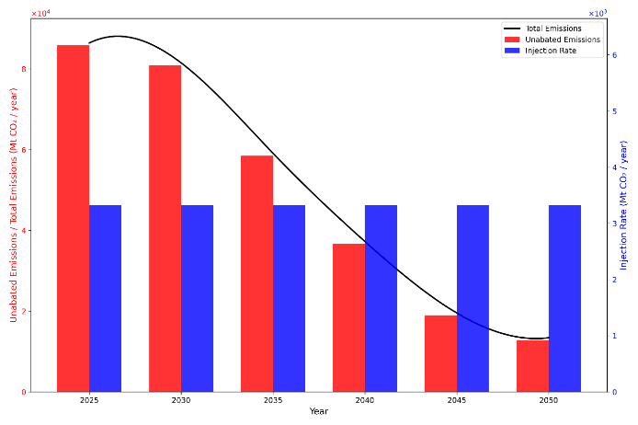
(d)
(c)
(b)
(a)
Figure 4: (a) The optimal location for synergistic alignment between CO₂ sources (industrial clusters) and CO₂ storage sinks. (b) Utilization plot at the 5x5 km grid level and (c) utilization plot at the provincial level. (d) injection rate vs. emission rate timeline. The spatial analysis reveals distinct patterns of industrial cluster proximity to geological storage sites. The purple-hatched shaded regions denote industrial facilities situated within a 250 km radius of potential storage locations, representing optimal candidates for CCS implementation using pipeline transportation infrastructure. TC: Textile and garment; ME: mechatronics and equipment; WF: wood furniture; AF: Food processing firms of agricultural and sideline products; MC: metallurgical, chemical, and resource rough processing; PM: pharmaceutical; PP: paper making; and OM: other manufacturing firms represent the classification of manufacturing industries (see Methods).
Analysis at the provincial level shows a divergence in geological CO₂ storage resource characteristics (Figure 4(c)). DSAs have substantial storage potential capacity but slower injection rates, typified by provinces such as Xinjiang and Heilongjiang, which possess total capacities exceeding 100,000 Mt yet relatively modest injection rates (below 20 MtCO₂/year). This profile positions them as strategic, long-term storage assets. EOR sites in several provinces, including Tianjin, Jiangsu, Liaoning, and Shandong, exhibit a “small but fast” profile, with more constrained total storage (below 800 Mt) but significantly higher injection rate capacities per unit of storage (above 30 MtCO₂/year). This makes them particularly suitable for rapid, near-term deployment to mitigate concentrated industrial emissions. Grid-level analysis confirms that this functional heterogeneity exists within provinces (Figure 4(b)). This observed duality implies that a two-pronged strategy is necessary: exploiting “small but fast” EOR resources for early, high-impact projects, while concurrently developing the vast “big but slow” DSA resources for the century-scale sequestration required to meet long-term climate objectives.
Figure 4(d) highlights the challenges confronting China’s pathway to carbon neutrality by 2060. Although the nation’s total CO₂ emissions are forecast to decline substantially, from over 86,000 Mt/year in 2025 to approximately 13,400 Mt/year by 2050 ³⁵, a critical bottleneck is evident. The rate of geological CO₂ injection capacity remains insufficient to manage the emission stream, resulting in a large and persistent gap of unabated CO₂ that endures through 2050. Consequently, even with falling total emissions, the volume of CO₂ that cannot be captured and stored remains high, ~13,000 Mt/year by mid-century. This analysis suggests that, under current storage rates, China’s carbon management strategy is not yet aligned with the net-zero trajectory. Achieving the 2060 goal necessitates a parallel and accelerated investment in the development of storage infrastructure, clean energy deployment, and energy efficiency to bridge this gap. Without such integrated efforts, the nation will lack the necessary carbon sink capacity to neutralize its hard-to-abate sectorial emissions, thereby jeopardizing the feasibility of its long-term target.
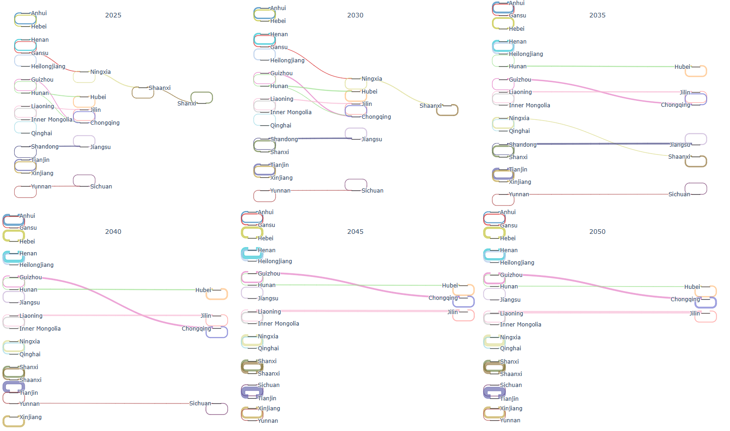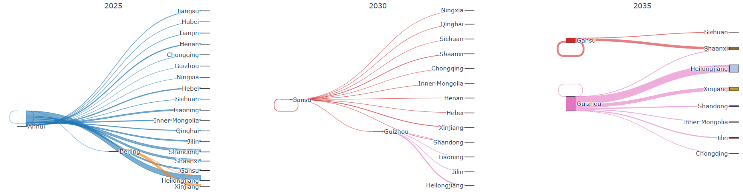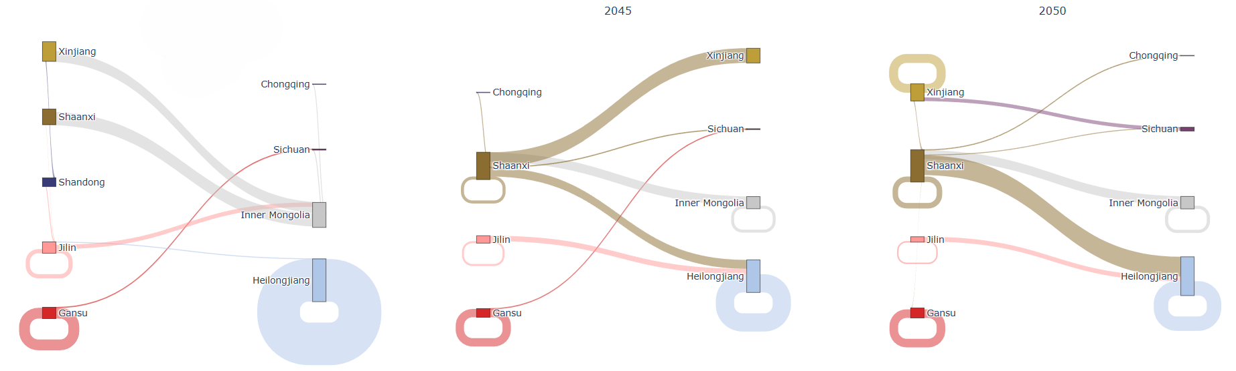
(b)
(a)
Figure 5: A Sankey diagram showing the flow of CO₂ from source sectors/provinces to (a) DSA and (b) EOR sink provinces for the MC manufacturing category. The width of the flows in (a) and (b) represents the average annual injection capacity rate of CO2 (Mt/yr) (see Supplementary Table 5). Provinces with a circular marker act as self-contained “source-and-sink” hubs, utilizing their own storage capacity first, while linear flows indicate provincial cross-boundary transport of CO₂.
We use Sankey diagrams to illustrate China’s decarbonization pathways for hard-to-abate sectors by tracking the flow of captured emissions to geological storage sites from 2025 to 2050. The analysis reveals a two-tiered storage strategy. Provinces such as Jiangsu, Shandong, and Hebei act as integrated hubs, sequestering a substantial share of their emissions locally through co-located storage resources, as visualized by circular markers and internal flow pathways (Figure 5(a)). In contrast, hard-to-abate clusters in provinces with limited storage potential require the development of cross-provincial transport networks to channel captured CO₂ to sink-rich provinces, including Xinjiang, Chongqing, and Qinghai (Figure 5(b)). The limited capacity of EOR sites is rapidly depleted, shifting the long-term storage burden toward the more abundant yet slower-injecting DSA. These findings highlight the critical need for strategic pipeline infrastructure to connect major hard-to-abate industrial centres with extensive DSA basins, thereby ensuring a permanent waste disposal route essential for meeting China’s climate objectives.

Spatial Coupling of Blue Hydrogen Production and CO₂ Storage
Hydrogen has been proposed ³⁶as a decarbonization substitute for fossil fuels in heavy industries ³⁶. Despite China’s status as the world’s largest hydrogen producer, 99% of its current output is grey hydrogen, from natural gas via steam methane reformation (SMR), while green hydrogen contributes less than 1% ³⁷. The integration of hydrogen into the future energy system faces a significant cost barrier, ranging from 3.20 to 8 USD/kg in 2024 ³⁸. Given that green hydrogen, produced through water electrolysis powered by renewable energy, remains comparatively expensive ^{39,40}, blue hydrogen from natural gas via SMR with CCS presents a cost-competitive alternative to conventional fossil fuels. The large-scale adoption of blue hydrogen is contingent on the minimization of associated CCS facility costs.
Figure 6 identifies optimal areas across China for the co-location of blue hydrogen production facilities with geological CO₂ storage reservoirs, highlighted by purple-hatched shading where the majority of China’s natural gas fields and storage potential fall within a 250 km radius. This strategic proximity is highly advantageous, as it substantially reduces the requirement for long-distance CO₂ transportation, a primary cost component within the CCS value chain. The most promising regions include north-eastern China, the Ordos Basin, central and eastern Sichuan, and specific areas within Xinjiang in the northwest, where extensive natural gas reserves overlap with substantial CO₂ storage capacity. Several southern coastal provinces demonstrate strong potential for co-location, supported by dense clusters of natural gas fields and proximal DSA storage resources. By integrating blue hydrogen production with local CCS infrastructure, these areas can achieve considerable cost advantages. Based on the priority regions identified, we estimate a potential for China to establish 20 to 30 major blue hydrogen production hubs by 2050, wherein multiple emission sources would utilize shared transport and storage infrastructure. For example, a region with substantial resources, such as the Ordos Basin, given its extensive natural gas reserves and coincident storage potential, could support 3–5 major facilities, whereas smaller regions might accommodate 1–2. The aggregate annual blue hydrogen production capacity from this national network of hubs is projected to range from 2.5 to 4.0 million tonnes (Mt H₂/year) by 2050 (see Methods).
.
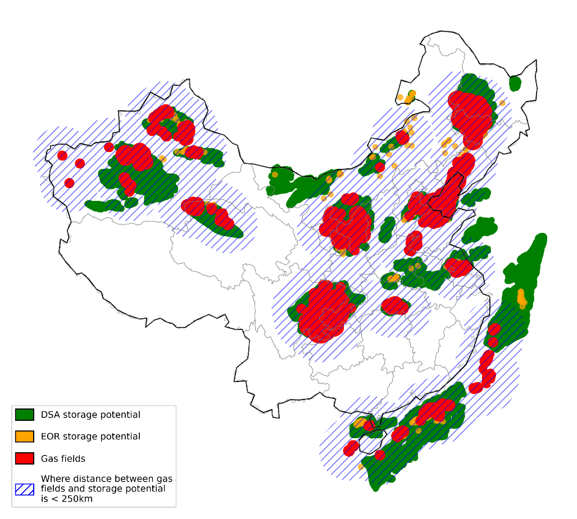
Figure 6: The optimal location for the blue-hydrogen facility. The purple-hatched shaded region shows areas located near natural gas fields and CO₂ geological storage sites within a 250 km radius.

Provincial Contribution to Emission Reduction
Supplementary Figure 21(a) presents the projected contribution of DSA-based CCS to provincial emission reductions between 2025 and 2050, which is the cumulative amount of CO₂ sequestered by a particular year relative to emissions in that year for each province. Provinces like Jiangsu (295%), Qinghai (126%), Tianjin (141%), Shandong (165%), Hebei (105%), and Anhui (79%) provide the largest contributions to sequestering about 4400 MtCO₂ by 2050, a pattern attributed to their substantial geological storage potential and comparatively high injection rate capacities. Many coastal and less geologically endowed provinces, such as Beijing, Fujian, Guangdong, Hainan, Jiangxi, Shanghai, Tibet, and Zhejiang, have no CCS contributions throughout the period, reflecting the absence of DSA-based storage capacity (Supplementary Table 8). EOR-based CCS (Supplementary Figure 21(b)) demonstrates strong performance in Shandong (260%), Jilin (167%), Qinghai (55%), and Jiangsu (48%) provinces by 2050 sequestering about 1100 Mt of CO₂, owing to the presence of mature oil fields that offer synergistic opportunities for combining CO₂ storage with enhanced oil recovery (Supplementary Table 9). EOR offers near-term emission reduction potential in hydrocarbon-rich regions, while DSA provides large-scale, long-term storage capacity in sedimentary basins, highlighting the complementary roles of EOR and DSA in China’s decarbonization strategy.
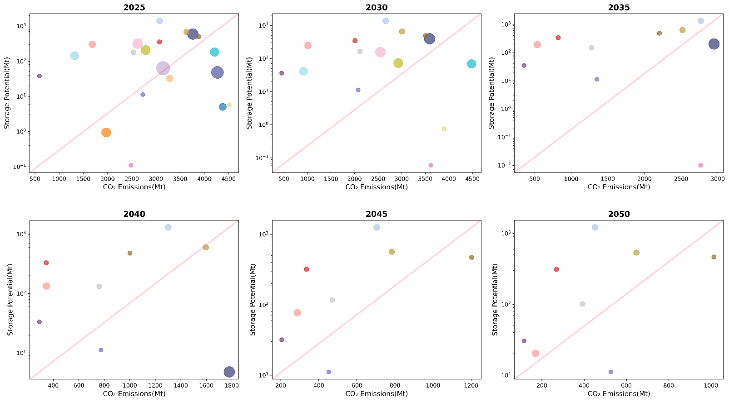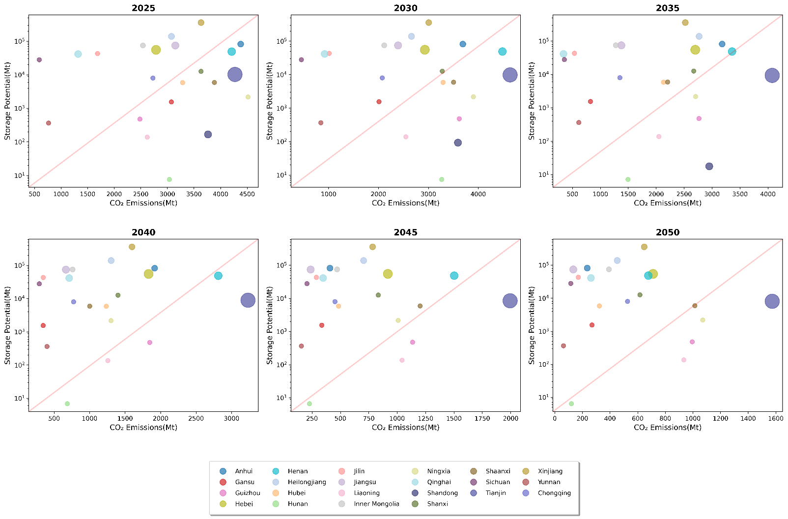
Figure 7: The responsibility vs. capability of each of the provinces for (upper panel) DSA and (lower panel) EOR. Each bubble represents a province, with its size indicating the average annual injection rate. The red diagonal line (y = x) serves as a benchmark: provinces above the line are “storage-rich”, while those below the line are “emission-rich”.
Figure 7(a) analyses DSA temporal distribution from 2025 to 2050, showing an upward shift of provincial data points as national emissions decline, while the inherent storage capacity remains fixed. Provinces including Xinjiang (with a storage-to-emissions ratio increasing from 99 in 2025 to 558 by 2050), Jiangsu (from 24 to 559), Jilin (from 26 to 255), Heilongjiang (from 45 to 309), Inner Mongolia (from 30 to 192), and Qinghai (from 32 to 158) persistently plot well above the parity line, indicating a consistent and robust storage surplus (see Supplementary Table 7). In contrast, highly industrialized eastern provinces such as Shandong (ratio declining from 0.04 in 2025 to 0 by 2040), Guizhou (0 for all years), Liaoning (0 for all years), and Hunan (0 for all years) remain below this line (see Supplementary Table 7), signalling a persistent storage deficit and a growing imperative to transport CO₂ to storage-endowed regions via pipelines or tank transportation. Figure 7(b) presents the corresponding analysis for EOR sites. In 2025, most provinces appear above the parity line, reflecting the early economic attractiveness and deployment of EOR, particularly in regions with active oil fields like Xinjiang (ratio of 0.2), and Heilongjiang (0.5) (see Supplementary Table 7). A distinct trend is seen: the number of provinces represented steadily decreases from over 20 in 2025 to just 8 by 2050 as their finite EOR capacity is fully allocated (see Supplementary Table 6). By 2050, the EOR landscape is considerably constrained, with only a few provinces, such as Xinjiang (0.8), Gansu (1.2) and Heilongjiang (2.7), maintaining a viable storage-to-emissions balance. This trajectory demonstrates that while EOR offers a near-term storage pathway, its limited capacity renders it insufficient for supporting China’s large-scale, long-term carbon management strategy.

Discussion and Policy Implications
CCS constitutes a critical technological pathway for China to achieve carbon neutrality. This study assesses CO₂ storage costs, source-sink matching, and provincial contributions to emission reduction, using a 5km resolution national dataset of onshore and offshore geological storage potential and injection rate capacity across 24 major sedimentary basins and 1,181 oilfields. While CCS is a central solution for decarbonizing hard-to-abate sectors, its deployment is constrained by cost, which varies with CO₂ concentration and project scale [1]. The analysis projects a dramatic decline in China’s full-chain CCS pipeline costs from 2025 to 2050 for both DSA and EOR, with pipeline transport being 14-29% cheaper than tanker systems. The study also reports specific minimum and 5th percentile cost benchmarks nationwide (see Supplementary Table 1-4). The assessment further delineates distinct storage profiles: EOR sites exhibit a “small-but-fast” characteristic suitable for near-term decarbonization, whereas DSA resources offer a “big-but-slow” capacity essential for long-term climate targets. Geospatial proximity-based ranking identifies optimal source-sink clusters for industrial emissions, particularly from hard-to-abate sectors in south-eastern and eastern China. We found prime blue hydrogen co-location zones in the Ordos Basin and north-eastern region. The co-location strategy lowers capital and operational costs of CO₂ transport and improves the scalability of blue hydrogen as a cost-competitive alternative to conventional fossil fuels. This spatial alignment of resources is critical for designing efficient hydrogen-CCS value chains and prioritizing regional investment in China’s transition to a low-carbon energy system. Our analysis highlights provincial disparity, dividing the country into “storage-rich” regions, such as Xinjiang, Inner Mongolia, and “emission-rich” provinces, including Shandong, Guizhou, highlighting the imperative for inter-provincial cooperation to enable a coordinated national CCS infrastructure. This cooperation would enable the strategic development of a national CO₂ pipeline network, allowing emission-rich provinces to offset their hard-to-abate industrial emissions by accessing the vast, cost-effective storage resources of storage-rich provinces, thereby ensuring a viable pathway to meet national carbon neutrality targets.
A clear downward trend in costs is projected from 2025 to 2050, driven by anticipated technological maturation and economies of scale. The consistent economic advantage of pipeline transport highlights the strategic imperative to develop shared pipeline infrastructure, particularly within optimal source-sink matching zones. This approach aligns with IEA assessments, which identify CCUS hubs with collective CO₂ transport and storage networks as a critical catalyst for accelerated deployment ⁴¹. The need for energy transition by reducing the share of fossil fuels in final energy consumption presents a concurrent opportunity to repurpose existing oilfield pipelines for CO₂ transport. This is particularly viable as the storage capacity of EOR sites, rapidly exhaustible, offers a near-term storage solution. This near-term use of EOR provides a planning and investment window for developing the extensive DSA resources required to meet long-term climate mitigation objectives.
Figure 8 reveals a distinct competitive advantage for China’s unit CCS costs relative to the European Union (EU) and the United States (USA) (see Supplementary Table 10). The disaggregated cost components show that China’s capture costs (32-43 USD/tonne) are broadly comparable to the lower end of the US range (25-30 USD/tonne) and significantly below the EU range. A more pronounced advantage is evident in transport and storage, where China’s pipeline transport (0.11-0.19 USD/tonne.km) and storage costs (7-8 USD/tonne) are a fraction of the integrated “transport and storage” costs reported in Western studies, which often range from 25-35 USD/tonne in the US and 8-40 USD/tonne in the EU. This substantial divergence could be due to lower labour and construction costs and potentially shorter planned distances for source-sink matching within our optimized model. However, this cost advantage exists within a very different policy context; both the EU and the US benefit from more mature regulatory frameworks and stronger financial drivers, such as the US 45Q tax credit ⁴² and the high EU Emissions Trading System (ETS) carbon price ^{43,44}, which can exceed the total CCS cost, thereby de-risking private investment. For China, these lower costs present an opportunity, but realizing them at scale depends on implementing similarly robust carbon pricing or fiscal incentives to bridge the remaining economic gap and attract the necessary capital for widespread CCS deployment.
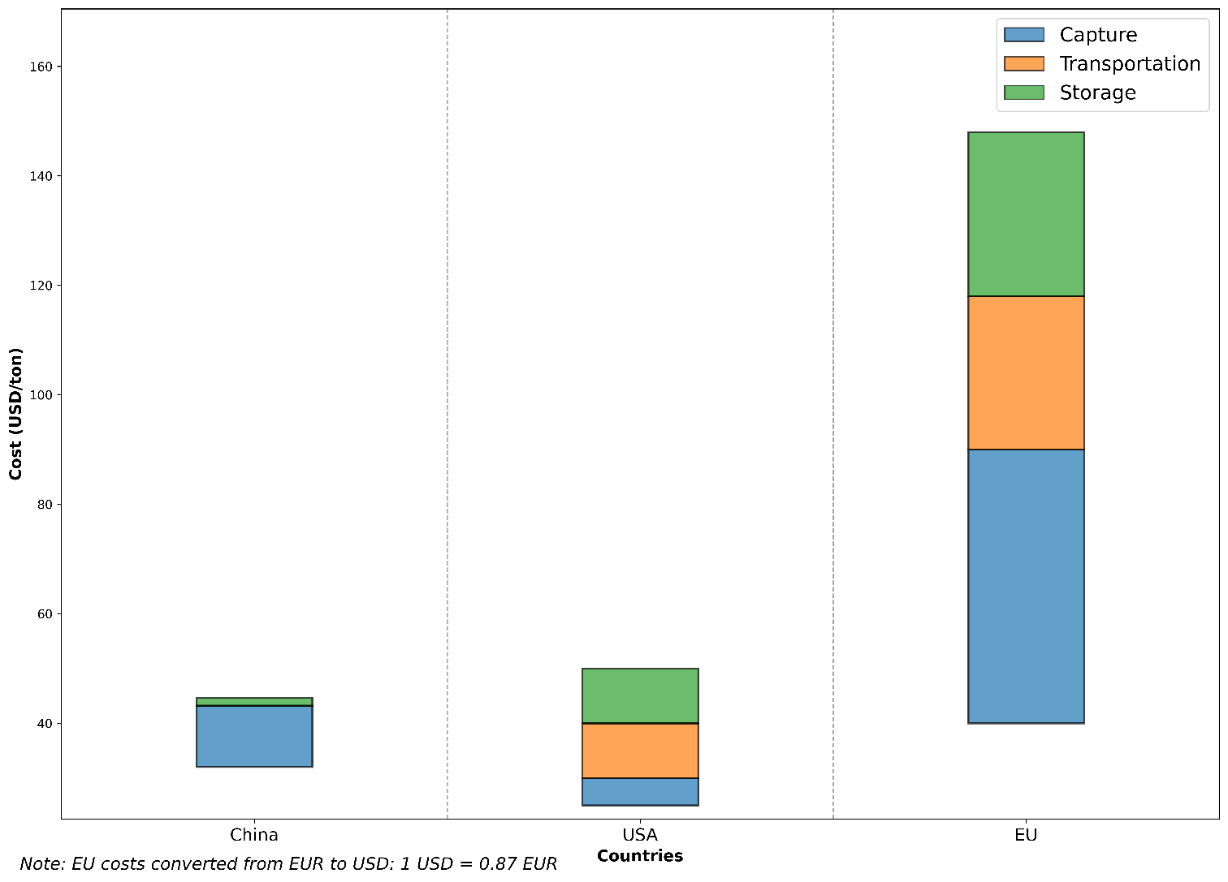
Figure 8: Comparison of CCS unit costs with reference to China.

Deployment priority should be given to integrated hubs, such as Jiangsu and Shandong, where dense hard-to-abate industrial clusters co-exist with nearby geological storage. These locations provide the cheapest decarbonization opportunities, allowing for rapid deployment with little transportation and infrastructure requirements. However, Figure 5(a) and Figure 5(b) show that this localized solution is insufficient on a national scale. A larger fraction of these emissions, particularly those from storage-poor provinces, must be transported across provincial borders. This creates a cross-provincial issue, requiring collaboration and strategic design for a national CO₂ pipeline network that connects emission hotspots with sink-rich regions. Ultimately, this long-term infrastructure must be designed with a clear end-state in mind, that is, a shift to DSA. While EOR provides a valuable “small-but-fast” bridge for early projects, its limited capacity is rapidly exhausted. The long-term decarbonization of China's hard-to-abate sector is, therefore, entirely contingent on the timely development and integration of the vast “big-but-slow” DSA resources, which form the only storage asset of sufficient scale to support the nation’s 2060 carbon neutrality goal.
Our integrated risk assessment highlights a key geomechanical constraint for China’s carbon management strategy. Expansive storage formations in the North China Plain and Xinjiang face increased risks of CO₂ leakage and seismicity due to their proximity to active tectonic faults, requiring a split strategy for site development. The initial focus should be on a group of high-capacity, low-risk DSA sites, which are critical assets for early, large-scale deployment. Demonstrating safe operation in these geologically stable areas will support creating regulatory frameworks and public trust. Also, the use of higher-risk, high-capacity reservoirs, essential for meeting national storage quotas, requires a strict management approach. Development in these zones must be based on strong monitoring, verification, and accounting (MVA) systems that are connected with financial assurance methods to handle long-term liability and potential remediation. This dual strategy ensures that storage security is maintained across geologically different locations while preserving the size of deployment required to satisfy climatic targets.
To accelerate CCS deployment, policymakers should consider policy support for early-stage development and demonstration of CCUS projects, implementing targeted subsidies, tax credits, or differentiated carbon price mechanisms that account for varying storage costs. DSA sites with higher sequestration costs should receive greater incentives than lower-cost EOR fields, thereby encouraging development across the full cost spectrum rather than concentrating projects solely in economically favourable locations. Without such, near-term market forces risk triggering a preferential “gold rush” on EOR due to its immediate economic returns, potentially diverting critical investment and delaying the build-out of essential DSA capacity. This approach would de-risk initial capital expenditure, stimulate technological learning, and secure the vast, long-term storage assets indispensable for achieving carbon neutrality, thereby aligning economic incentives with overarching climate security objectives. Strategic designation of CCS Hub Priority Development Zones at the national level could optimize infrastructure deployment through integrated CO₂ trunk pipelines, shared compression facilities, and unified permitting processes. Provincial governments must incorporate CCS capacity targets into their five-year climate plans, carefully aligned with region-specific geological constraints and validated injection rate limitations.
Strategic development of specialized hydrogen-CCS industrial parks should be prioritized in regions where natural gas resources, CO₂ storage capacity, and industrial demand clusters are co-located, supported by expedited permission for integrated hydrogen-CCS facilities. A risk-based regulatory framework should be implemented, with streamlined approvals for low-risk sites and strengthened requirements, including rigorous monitoring systems, financial assurance mechanisms, and emergency response plans, for higher-risk locations. To maintain decision-making relevance, a dynamically updated CCS deployment mapping system should be instituted, with revisions made every 3-5 years to incorporate the latest geological surveys, industrial activity data, and infrastructure developments. This would ensure ongoing optimization of site selection based on both economic and risk considerations. China’s export-oriented industries should be incentivized to adopt CCS technologies to comply with emerging carbon border adjustment mechanisms and international green supply chain requirements, positioning domestic manufacturers competitively in low-carbon global markets.
China’s commitment to become carbon neutral by 2060 confronts a serious implementation gap, since the theoretical CCS potential is unmatched by a strategic framework for cost-effective and safe large-scale deployment. Existing evaluations frequently lack the spatial resolution and breadth of information required to generate effective investment roadmaps. This study uses a high-resolution geospatial dataset to identify CO₂ storage sites and determine effective CCS implementation pathways to meet national climate targets. Our analysis identifies optimal regions where costs can be as low as the 5th percentile, projecting a decline from 2346 USD/km in 2025 to 303 USD/km by 2050, sequestering about 3 – 18 MtCO₂/year. Pipeline transport is 14-29% more cost-effective than tanker transport for both DSA and EOR from 2025 to 2050, emphasising the strategic importance of pipeline infrastructure for scalable implementation. A dual-track storage strategy is proposed in which the large capacity of DSA is set aside for long-term sequestration while EOR, with its faster exhaustion profile, is given preference for near-term injection.
Our study shows that eastern and south-eastern China are most suited for source-sink cluster development, whereas the north-eastern region and the Ordos Basin offer excellent places for blue hydrogen co-location. We can estimate that China has the potential to develop 20-30 blue hydrogen production hubs with a total annual capacity of 2.5 - 4.0 million tonnes of hydrogen by 2050. A provincial-level assessment finds a significant difference between storage-rich and emission-intensive locations, necessitating strong inter-provincial collaboration. This approach thereby transforms CCS from a theoretical contingency to an actionable, investable component of national climate policy, serving as a key connection between ambition and practical implementation. Without such spatially detailed planning, CCS may remain a symbolic pledge rather than a deployable solution. While constrained by uncertainties inherent in subsurface modelling and simplified economic indices, this study establishes a foundational roadmap, with future work recommended to incorporate dynamic plume modelling, high-resolution infrastructure routing, and probabilistic risk frameworks. In conclusion, this analysis provides the indispensable connection between China’s carbon neutrality goal and the optimized, secure deployment of CCS required to achieve it.

Methods
This study uses a high-resolution dataset of carbon geological storage potential and injection rate capacity for deep saline aquifers (DSA) and enhanced oil recovery (EOR) systems located onshore and offshore across China. With a grid resolution of 5 km x 5 km, the dataset encompasses 1,181 oilfields and 69 reservoirs distributed within 24 major sedimentary basins ²⁰. A comprehensive assessment of China’s CO₂ storage resources is made possible by this dataset’s high spatial resolution, which can be scaled from localised grid-level analysis to more extensive assessments at the county, provincial, and basin-wide levels ²⁰.

Economic Analysis
We model the full-chain costs of CCS, encompassing capture, transportation (via truck or pipeline), and storage. Cost estimates for each stage, derived from an analysis of existing CCUS projects in China, are presented in Table 1 ⁴⁵ (see Supplementary Table 11 for the original costs in Chinese Yuan (CNY)).
Table 1: The economic cost of each component of the full chain CCS system ^{45–47}. 1 USD = 7.183 CNY.
Year |  | 2025 | 2030 | 2035 | 2040 | 2045 | 2050
Capture Cost (USD/tonne) | Pre-combustion | 13.92 - 25.06 | 12.53 - 18.10 | 9.75 - 11.14 | 6.96 - 9.75 | 4.18 - 6.96 | 2.78 - 5.57
Capture Cost (USD/tonne) | Post-combustion | 32.02 - 43.16 | 26.45 - 38.98 | 22.27 - 30.63 | 13.92 - 25.06 | 11.14 - 20.88 | 9.75 - 16.71
Capture Cost (USD/tonne) | Oxy-fuel combustion | 41.77 - 66.82 | 22.27 - 54.29 | 18.10 - 44.55 | 15.31 - 32.02 | 12.53 - 20.88 | 11.14 - 18.10
Transportation (USD/tonne.km) | Tank | 0.13 - 0.19 | 0.11 - 0.18 | 0.10 - 0.17 | 0.08 - 0.15 | 0.07 - 0.15 | 0.07 - 0.14
Transportation (USD/tonne.km) | Pipeline | 0.11 | 0.10 | 0.08 | 0.07 | 0.07 | 0.06
Storage cost (USD/tonne) |  | 6.96 - 8.35 | 5.57 - 6.96 | 4.87 - 5.57 | 4.18 - 4.87 | 3.48 - 4.18 | 2.78 - 3.48

Given the prevailing adoption of post-combustion capture technology in CCUS deployments across the globe, we base our cost calculations on this method to ensure consistency with real-world applications ⁴⁶. Furthermore, we evaluate three cost scenarios reflecting the minimum, maximum, and average unit costs, derived from the ranges presented in Table 1, as shown in Table 2 (see Supplementary Table 12 for the original costs in CNY).
Table 2: Minimum, maximum, and average costs of each segment of the full chain CCS system.
Year | Post-Combustion Capture (USD/tonne) | Tank Transport (USD/tonne.km) | Pipeline Transport (USD/tonne.km) | Storage (USD/tonne)
 | Min / Mean / Max | Min / Mean / Max | Fixed | Min / Mean / Max
2025 | 32.02 / 37.59 / 43.16 | 0.13 / 0.16 / 0.19 | 0.11 | 6.96 / 7.66 / 8.35
2030 | 26.45 / 32.72 / 38.98 | 0.11 / 0.15 / 0.18 | 0.10 | 5.57 / 6.27 / 6.96
2035 | 22.27 / 26.45 / 30.63 | 0.10 / 0.13 / 0.17 | 0.08 | 4.87 / 5.22 / 5.57
2040 | 13.92 / 15.31 / 25.06 | 0.08 / 0.12 / 0.15 | 0.07 | 4.18 / 4.53 / 4.87
2045 | 11.14 / 16.01 / 20.88 | 0.07 / 0.11 / 0.15 | 0.07 | 3.48 / 3.83 / 4.18
2050 | 9.75 / 13.23 / 16.71 | 0.07 / 0.10 / 0.14 | 0.06 | 2.78 / 3.13 / 3.48

The economic model evaluates the total investment cost for the full-chain CCS system in each grid cell i according to Equation (1):
$${Cost}_{t,i}= {uc}_{t}* {CCS}_{cap,t,i}$$ | (1)
where ${uc}_{t}$ represents the unit abatement cost in year t, comprising the sum of capture (C), transportation (T), and storage (S) unit costs, and ${CCS}_{cap,t,i}$ denotes the annual volume of CO₂ captured and stored in grid cell i. For modelling purposes, we equate ${CCS}_{cap,t,i}$ to the injection rate at each grid cell.
Based on established literature, the distance (d) between emission sources and storage sites must be within 250 km, beyond which an additional compressor station to maintain supercritical flow is required (see Supplementary Table 13) ⁴⁶. Analysis indicates that integrating such infrastructure increases transportation costs by 30% to 100%, contingent upon pipeline-specific design parameters, total distance, and terrain complexity ^{48,49}. To model the economically optimal scenario, the full-chain cost per kilometre is therefore calculated for distances (d) not exceeding this 250 km threshold, as defined by Equation (1):
$${Cost}_{t,i}= \left(\frac{\left(C+S\right)*R_{i}}{d}\right)+T*R_{i}$$ | (2)
To ensure unit consistency within the cost calculations formalized by Equation (2), the injection rate (Mt/year) and storage potential (Mt) are converted to tonnes. The geological storage capacity represents a finite resource within each grid cell. Consequently, under the assumption of zero leakage (Equation 3), the remaining storage potential diminishes annually (see Supplementary Table 6):
$$S_{i,t}= S_{2025}- R_{i}*(t-2025)$$ | (3)
where $S_{2025}$ indicates the initial storage capacity. Subsequent annual injection rates beyond 2025 are determined through Equation (4):
$$R_{i,t}= min⁡(R_{i} ,S_{i,t})$$ | (4)

Seismic Risk Factor Calculation
The seismic risk factor for EOR and DSA carbon storage sites across China is derived through a spatially explicit, probabilistic multi-hazard framework that integrates seismic ground motion hazard, tectonic proximity, and site-specific geotechnical vulnerability. This approach synthesizes the primary physical mechanisms contributing to seismic risk for subsurface storage infrastructure: the intensity of shaking expected at the site, the influence of nearby active faults, and the potential amplification of ground motions due to local soil conditions ⁵⁰. The final seismic risk factor, R, is formulated as a weighted linear combination of three normalized component scores as expressed in Equation (5):
$$R=w_{1}*S_{PGA}+w_{2}*S_{FP}+w_{3}*S_{SA}$$ | (5)
Where $S_{PGA}$ is the peak ground acceleration hazard score, $S_{FP}$ is the fault proximity risk score, and $S_{SA}$ is the site amplification vulnerability score. The weighting coefficients $w_{1}$, $w_{2}$, $w_{3}$ satisfying $w_{1}$ + $w_{2}$ + $w_{3}$ = 1, reflecting the relative importance assigned to each risk driver. In this national-scale assessment, a weighting scheme of (0.5, 0.3, 0.2) is adopted, based on expert elicitation and precedence in critical infrastructure risk frameworks, which prioritizes the direct shaking hazard while incorporating tectonic and site effects in a meaningful manner. This additive model provides a transparent and computationally efficient metric for comparative risk ranking across hundreds of fixed-location storage sites. Acknowledging that more complex multiplicative or nonlinear interactions may exist, the linear form offers stability and clarity for a first-order national assessment.
The ground motion hazard score, $S_{PGA}$, is calculated using probabilistic seismic hazard analysis (PSHA) outputs for mainland China. We utilize the time-dependent PSHA developed by Xu et al. ⁵¹, which integrates multiple seismic source models, including area sources, fault sources, and seismic risk areas, with updated seismicity parameters for the period 2021–2030. PGA values, representing the severity of expected shaking, are extracted directly at the coordinates of each of the 527 storage sites from hazard maps for six exceedance probabilities (63%, 10%, 5%, 2%, 1%, and 0.5% in 50 years) (Supplementary Figure 16). To render these absolute acceleration values into a dimensionless, comparable risk score, a spatial normalization is applied (Equation (6):
$$S_{PGA}\left(p\right)= \left(\frac{PGA \left(p\right)}{{PGA}_{max}\left(p\right)}\right)*10$$ | (6)
Where $PGA \left(p\right)$ is the site-specific PGA value at probability level p, and ${PGA}_{max}\left(p\right)$ is the maximum PGA value observed across all of China for that same probability. This transformation scales the score from 0 to 10, preserving the relative spatial distribution of seismic hazard across the country. The 10% in 50-year probability (475-year return period) hazard level serves as the primary basis for the risk calculations, representing a standard for important infrastructure design ⁵¹.
The fault proximity risk score, $S_{FP}$, quantifies the heightened risk associated with a storage site’s vicinity to active tectonic structures. This component integrates both the intrinsic hazard potential of the nearest fault and the geometric decay of influence with distance. The intrinsic fault hazard is characterized by a Fault Activity Risk Score (FARS) (see Supplementary Figure 14), calculated for each fault segment in the China Active Fault Database (CAFD400) based on its most recent activity and kinematic behaviour (Table 3) ⁵². The FARS is computed as:
$$FARS=\left(W_{age}*1.5\right)+ W_{fea}$$ | (7)
Where $W_{age}$ is a weight assigned based on the fault's latest active period (with Holocene faults receiving the highest weight), and $W_{fea}$ is a weight based on fault type and detectability (with buried or inferred faults receiving the highest weight due to greater epistemic uncertainty). The multiplier of 1.5 amplifies the influence of recent activity, reflecting its critical role in contemporary hazard.
Table 3: Age-weight assignment based on the latest active period and fault property weight ($W_{fea}$​​) based on kinematic type and detectability.
Age |  | Fault Property
Latest Active Period | Age Weight ($W_{age}$) | Fault Type Category | Fault Property Weight ($W_{fea}$​)
Holocene (Qh) | 4 | Buried / Inferred (any subtype) | 4
Late Pleistocene (Qp3) | 3 | Complex oblique-slip (e.g., left/right lateral normal, normal-strike-slip, reverse strike-slip) | 3
Middle-Early Pleistocene (Qp1+2) | 2 | Simple slip (normal, reverse, strike-slip, left/right lateral) | 2
Pre-Quaternary (pre-Q) | 1 | Low-hazard types (exposed, flexural slip, tear fault) | 1
For a storage site located a distance d (in kilometres) from a fault with a given FARS, the fault proximity score is modeled using an exponential decay function as depicted in Equation (8):
$$S_{FP}\left(p\right)=FARS*\exp^{\left(-\frac{d}{λ}\right)}$$ | (8)
The decay constant λ defines the characteristic distance over which the fault influence diminishes. A default value of λ=200 km is used, consistent with the typical zone of influence for major continental faults. This formulation captures the intuitive principle that risk is highest when sitting directly on a recently active fault, and seismic wave amplitude decreases smoothly with distance due to geometric spreading and anelastic attenuation ^{53,54}.
The site amplification vulnerability score, $S_{SA}$, accounts for the modification of bedrock ground motions by local near-surface geology. The key parameter for estimating this amplification is the time-averaged shear-wave velocity in the upper 30 meters, $V_{S30}$. For this study, we employ a newly developed, high-resolution VS30​ map for mainland China at 30-arcsecond resolution, generated using a refined Slope-based Cokriging (SCK) model ⁵⁵. This model spatially integrates 7,939 local $V_{S30}$​ measurements (7,797 boreholes plus 142 strong-motion stations) with topographic slope data via a multivariate geostatistical framework. The SCK estimator at a target location $x_{0}$​ is given by Equation (9):
$$V_{S30}^{SCK}\left(x_{0}\right)=\sum_{∝ϵS_{vs}}{λ_{vs}\left(α\right)}V_{S30}\left(α\right)+\sum_{βϵS_{slp}}{λ_{slp}\left(β\right)}Slp\left(β\right)$$ | (9)
Where $λ_{vs}$ and $λ_{slp}$ are weights solved through a Cokriging system that models the spatial autocorrelation and cross-correlation between $V_{S30}$​ and slope. This method provides a more accurate and spatially continuous estimate than global slope proxies, particularly in complex terrains. The derived $V_{S30}$​ value at each storage site is then used in the empirical ground motion model by Boore et al.³² to calculate a linear site amplification factor, F as expressed in Equation (10):
$$In\left(F\right)=b*In\left(\frac{V_{S30}}{V_{ref}}\right)$$ | (10)
With b =-1.186 and $V_{ref}$=760 m/s. The amplification factor is subsequently transformed into a normalized vulnerability score bounded between 0 and 10:
$$S_{SA}=\left(\frac{F-0.5}{3.0-0.5}\right)*10$$ | (11)
Where the bounds of 0.5 and 3.0 for F are based on empirical limits observed in global ground motion databases ³². This scoring reflects higher vulnerability (higher score) for softer sites with lower $V_{S30}$​​ that exhibit greater amplification.
To rigorously evaluate the robustness of the resulting risk rankings and to quantify the influence of epistemic uncertainties in model parameters, a comprehensive sensitivity analysis is conducted. This analysis systematically varies three key inputs: the fault influence decay distance λ (across 50, 100, 200, 300, and 500 km), the PGA hazard exceedance probability (across all six available levels), and the site amplification methodology (comparing the Boore et al. model ³², the Chinese seismic code GB 50011-2010 approach ³³, and a no-amplification baseline). For each sensitivity scenario, the complete risk calculation (Equation 1) is recomputed, producing 14 distinct risk assessments (5 fault λ values + 6 PGA levels + 3 amplification methods) in addition to the base case. This approach enables quantification of parameter influence through comparison of resulting risk scores and spatial risk patterns.

Spatial Coupling of Emission Sources and Storage Sinks
To identify regions with the highest potential for synergistic alignment between CO₂ emission sources (industrial clusters) and geological storage sinks across China, we use a gridded manufacturing dataset (GMD) ⁵⁶ that maps Chinese industrial facilities at 1×1 km resolution. This dataset lists manufacturing firms across eight distinct industrial categories for both 2015 and 2019 (Supplementary Table 14). Our analysis specifically uses the 2019 data, processed according to the same methodological framework described earlier. Through geospatial overlay analysis, we systematically match emission sources with potential storage sites, focusing on identifying optimal pairings where sources and sinks are within a 250 km radius (Supplementary Figure 20). This proximity constraint considers practical aspects of cost-effective CO₂ transport infrastructure development.

Spatial Coupling of Blue Hydrogen Production and Storage Sinks
Our analysis identifies optimal locations for blue hydrogen production by integrating CO₂ storage potential with existing energy infrastructure and industrial capacity. ⁵⁷We extract China-specific oil and gas field data from the Global Oil & Gas Features Database ⁵⁷, applying consistent processing methods as previously described. From the industrial manufacturing classification scheme (GMD), we focus on hydrogen-relevant manufacturing sectors, including: Mechatronics and Equipment (ME19), Metallurgical Chemical Industry and Resource Processing (MC19), and Pharmaceutical Manufacturing (PM19) ⁵⁶. Through advanced GIS techniques, we conduct multi-criteria spatial analysis incorporating: geological storage capacity, natural gas field distribution, and hydrogen-related manufacturing industrial clusters. The methodology employs proximity-based ranking, identifying candidate locations where all three critical elements fall within a 250 km radius, a distance constraint reflecting practical economic considerations for hydrogen production and carbon management infrastructure.
The production of blue hydrogen via conventional steam methane reforming (SMR) is characterized by a significant carbon footprint, generating approximately 10–11 tonnes of CO₂ for every tonne of hydrogen produced ⁵⁸. This results in a CO₂-to-H₂ mass ratio of roughly 10:1. The potential annual blue hydrogen production capacity for China by mid-century was estimated by linking the national CO₂ geological storage potential with the stoichiometric and energetic requirements of steam methane reforming (SMR) with CCS. The calculation is based on the premise that the scale of blue hydrogen production is directly constrained by the available and allocated CO₂ storage capacity. The total storage resource allocated for hydrogen, $S_{H_{2}}$ (in MtCO₂), was derived from a fraction of the national technical potentials for EOR and DSA, as defined in our study (Equation (12)):
$$S_{H_{2}}=α*S_{EOR}+ β*S_{DSA}$$ | (12)
Where $S_{EOR}$ and $S_{DSA}$ are the total technical sequestration potentials (822.6 and 7,505.1 MtCO₂ by 2050, respectively), and α (0.3) and β (0.05) are the allocation factors representing the portion of each resource dedicated to hydrogen production. This total allocated storage was then converted into an average annual hydrogen production capacity, H_{avg} (Mt H₂/year), over an assumed project lifespan, L, of 30 years, using the standard CO₂-to-H₂ mass ratio, r = (10:1)​​, for SMR-CCS (Equation (13)):
$$H_{avg}=\frac{S_{H_{2}}}{L*r}$$ | (13)
To reflect the projected infrastructure ramp-up and operational maturity by 2050, the average annual production was scaled by a dynamic deployment factor, k (1.5–2.0), yielding our final estimated capacity range for mid-century (Equation (14)):
$$H_{2050}=k*H_{avg}$$ | (14)

Provincial Contribution to Emission Reduction
Our analysis evaluates provincial-level contributions to carbon emission reductions across China, as quantified by Equation (15):
$$C_{j,t}=\frac{\left(t-2025\right)*R_{j,t}}{{emis}_{j,t}}*100$$ | (15)

where $C_{j,t}$ represents the CCS-mediated emission reduction for province j, $R_{j,t}$ denotes the province-specific average injection rate, and ${emis}_{j,t}$ corresponds to provincial carbon emissions in year t. We employ injection rates rather than CCS facility capture capacities in our calculations, reflecting the operational reality that most facilities transport captured CO₂ across provincial boundaries for geological storage ⁹. The model incorporates storage depletion dynamics while maintaining a fixed upper bound for cumulative sequestration capacity equivalent to the maximum geological storage potential. Provincial carbon emission projections from 2025 through 2050 were sourced from ³⁵, while Supplementary Table 5 presents the aggregated data on provincial storage capacities and corresponding average injection rates ²⁰.

References
1. UNEP. Emissions Gap Report 2025. United Nations Environment Programme (UNEP) https://www.unep.org/resources/emissions-gap-report-2025 (2025).
2. IPCC. Climate Change 2023: Synthesis Report. Contribution of Working Groups I, II and III to the Sixth Assessment Report of the Intergovernmental Panel on Climate Change . (Geneva, Switzerland, 2023). doi:10.59327/IPCC/AR6-9789291691647.
3. IEA. Net Zero Roadmap: A Global Pathway to Keep the 1.5 °C Goal in Reach. IEA, Paris https://www.iea.org/reports/net-zero-roadmap-a-global-pathway-to-keep-the-15-0c-goal-in-reach (2023).
4. WEF. ‘Hard-to-abate’ sectors are reducing emissions, here’s how they can accelerate progress towards net zero. World Economic Forum https://www.weforum.org/stories/2024/12/net-zero-hard-to-abate-sectors-decarbonization/ (2024).
5. WEF. Net-Zero Industry Tracker 2024 Edition. World Economic Forum https://reports.weforum.org/docs/WEF_Net_Zero_Industry_Tracker_2024.pdf (2024).
6. Byers, E. et al. AR6 Scenarios Database. Preprint at https://doi.org/10.5281/zenodo.5886911 (2022).
7. IEA. CCUS in Clean Energy Transitions. IEA, Paris https://www.iea.org/reports/ccus-in-clean-energy-transitions (2020).
8. IEA. CCUS Projects Database. IEA, Paris https://www.iea.org/data-and-statistics/data-product/ccus-projects-database (2025).
9. CO2Re. Facilities Database. Global CCS Institute https://co2re.co/FacilityData (2025).
10. Lebling, K., Gangotra, A., Hausker, K. & Byrum, Z. 7 Things to Know About Carbon Capture, Utilization and Sequestration. World Resources Institute https://www.wri.org/insights/carbon-capture-technology (2025).
11. Climate Watch. Historical GHG Emissions. Climate Watch https://www.climatewatchdata.org/ghg-emissions?end_year=2022&start_year=1990 (2025).
12. Gidden, M. J. et al. A prudent planetary limit for geologic carbon storage. Nature 645, 124–132 (2025).
13. Zhong, Z. et al. Role of CO2 geological storage in China’s pledge to carbon peak by 2030 and carbon neutrality by 2060. Energy 272, 127165 (2023).
14. Crippa, M. et al. GHG emissions of all world countries - 2025 Report. Publications Office of the European Union, Luxembourg https://doi.org/https://data.europa.eu/doi/10.2760/9816914 (2025) doi:https://data.europa.eu/doi/10.2760/9816914.
15. Oxford Institute for Energy Studies. Unpacking China’s 2060 carbon neutrality pledge. Oxford Institute for Energy Studies https://www.oxfordenergy.org/wpcms/wp-content/uploads/2020/12/Unpacking-Chinas-carbon-neutrality-pledge.pdf (2020).
16. Liu, H., Evans, S., Zhang, Z., Song, W. & You, X. The Carbon Brief Profile: China. Carbon Brief https://interactive.carbonbrief.org/the-carbon-brief-profile-china/index.html (2023).
17. IEA. Coal 2024. IEA, Paris https://www.iea.org/reports/coal-2024 (2024).
18. NBSC. Energy Production in December 2024. National Bureau of Statistics of China https://www.stats.gov.cn/english/PressRelease/202501/t20250124_1958444.html (2025).
19. OGCI. CCUS in China: The value and opportunities for deployment. Oil and Gas Climate Initiative https://www.ogci.com/wp-content/uploads/2023/05/China_CCUS_paper_September_2021.pdf (2021).
20. Fan, J.-L. et al. Dataset of CO2 geological storage potential and injection rate capacity in China based on fine grid technology. Sci Data 12, 640 (2025).
21. Sori, A., Moghaddas, J. & Abedpour, H. Comprehensive review of experimental studies, numerical modeling, leakage risk assessment, monitoring, and control in geological storage of carbon dioxide: Implications for effective CO2 deployment strategies. Greenhouse Gases: Science and Technology 14, 887–913 (2024).
22. Rui, Z., Zeng, L. & Dindoruk, B. Challenges in the Large-Scale Deployment of CCUS. Engineering 44, 17–20 (2025).
23. Nassabeh, M., You, Z., Keshavarz, A. & Iglauer, S. Sub-surface geospatial intelligence in carbon capture, utilization and storage: A machine learning approach for offshore storage site selection. Energy 305, 132086 (2024).
24. Kim, T. W., Kohli, A., Li, Y. & Kovseck, A. R. Wellbore Leakage and Seismic Risk Assessments for Geological Carbon Dioxide Storage in Saline Formations in Kern County, California. in SPE Western Regional Meeting (SPE, 2023). doi:10.2118/212989-MS.
25. Fang, H. et al. Potential assessment of CO2 source/sink and its matching research during CCS process of deep unworkable seam. Sci Rep 14, 17206 (2024).
26. Sun, L. et al. Source-sink matching and cost analysis of offshore carbon capture, utilization, and storage in China. Energy 291, 130137 (2024).
27. Li, K. et al. A national-scale high-resolution CCUS-shared pipeline layout for retrofitting multisectoral plants via onshore-offshore geological storage. iScience 27, 110978 (2024).
28. Wang, Y. et al. Unveiling cost reduction potential of carbon capture and storage clusters in China under multiple uncertainties. iScience 28, 113315 (2025).
29. Tang, H., Chen, W., Zhang, S. & Zhang, Q. China’s multi-sector-shared CCUS networks in a carbon-neutral vision. iScience 26, 106347 (2023).
30. Chang, K. W., Yoon, H. & Martinez, M. J. Potential Seismicity Along Basement Faults Induced by Geological Carbon Sequestration. Geophys Res Lett 49, (2022).
31. Cheng, Y. et al. Seismicity induced by geological CO2 storage: A review. Earth Sci Rev 239, 104369 (2023).
32. Boore, D. M., Stewart, J. P., Seyhan, E. & Atkinson, G. M. NGA-West2 Equations for Predicting PGA, PGV, and 5% Damped PSA for Shallow Crustal Earthquakes. Earthquake Spectra 30, 1057–1085 (2014).
33. NSPRC. Code for Seismic Design of Buildings (GB 50011-2010). National Standard of the People’s Republic of China (NSPRC) https://www.codeofchina.com/standard/GB50011-2010(2016).html (2010).
34. Yang, X., Nielsen, C. P., Song, S. & McElroy, M. B. Breaking the hard-to-abate bottleneck in China’s path to carbon neutrality with clean hydrogen. Nat Energy 7, 955–965 (2022).
35. Li, Y. et al. Hourly carbon emission factors of 31 provinces and cities in China from 2025 to 2060. Figshare https://doi.org/10.6084/m9.figshare.28953545.v2 (2025) doi:10.6084/m9.figshare.28953545.v2.
36. Johnson, N. et al. Realistic roles for hydrogen in the future energy transition. Nature Reviews Clean Technology https://doi.org/10.1038/s44359-025-00050-4 (2025) doi:10.1038/s44359-025-00050-4.
37. WEF. Green Hydrogen in China: A Roadmap for Progress. World Economic Forum https://www3.weforum.org/docs/WEF_Green_Hydrogen_in_China_A_Roadmap_for_Progress_2023.pdf (2023).
38. IEA. Global Hydrogen Review 2025. IEA, Paris https://www.iea.org/reports/global-hydrogen-review-2025 (2025).
39. Bhashyam, A. 2023 Hydrogen Levelized Cost Update: Green Beats Gray. BloombergNEF https://about.bnef.com/blog/2023-hydrogen-levelized-cost-update-green-beats-gray/ (2023).
40. Schelling, K. Green Hydrogen to Undercut Gray Sibling by End of Decade. BloombergNEF https://about.bnef.com/blog/green-hydrogen-to-undercut-gray-sibling-by-end-of-decade/ (2023).
41. IEA. Tracking Clean Energy Progress 2023. IEA, Paris https://www.iea.org/reports/tracking-clean-energy-progress-2023 (2023).
42. Global CCS Institute. U.S. Preserves and Increases 45Q Credit in “One Big Beautiful Bill Act”. Global CCS Institute https://www.globalccsinstitute.com/u-s-preserves-and-increases-45q-credit-in-one-big-beautiful-bill-act/ (2025).
43. ICAP. EU Emissions Trading System (EU ETS). International Carbon Action Partnership https://icapcarbonaction.com/en/ets/eu-emissions-trading-system-eu-ets (2025).
44. European Commission. EU Emissions Trading System. European Commission https://climate.ec.europa.eu/eu-action/carbon-markets/eu-emissions-trading-system-eu-ets_en (2025).
45. Liu, G., Cai, B., Li, Q., Zhang, X. & Ouyang, T. China’s pathways of CO2 capture, utilization and storage under carbon neutrality vision 2060. Carbon Manag 13, 435–449 (2022).
46. Wang, P. et al. CCUS development in China and forecast its contribution to emission reduction. Sci Rep 13, 17811 (2023).
47. ADB. Road Map Update for Carbon Capture, Utilization, and Storage Demonstration and Deployment in the People’s Republic of China. https://www.adb.org/publications/road-map-update-carbon-capture-utilization-storage-prc (2022) doi:10.22617/TCS220232-2.
48. Global CSS Institute. Economic Assessment of Carbon Capture and Storage Technologies: 2011 Update,. Global CSS Institute. Australia https://coilink.org/20.500.12592/8wz6rk (2011).
49. Itula, A. et al. Clean Energy Technology Observatory: Carbon Capture, Utilisation and Storage in the European Union - 2024 Status Report on Technology Development, Trends, Value Chains and Markets,. https://publications.jrc.ec.europa.eu/repository/handle/JRC134999 (2023) doi:10.2760/0287566.
50. Kumar, A. & Ghosh, G. Assessment of soil amplification effects on the seismic vulnerability of irregular reinforced concrete buildings of varying heights. Sci Rep 15, 34057 (2025).
51. Xu, W., Wu, J. & Gao, M. Seismic Hazard Analysis of China’s Mainland Based on a New Seismicity Model. International Journal of Disaster Risk Science 14, 280–297 (2023).
52. Wu, X. et al. The China Active Faults Database (CAFD) and its web system. Earth Syst Sci Data 16, 3391–3417 (2024).
53. Shrivastava, A., Liu, K. H. & Gao, S. S. Teleseismic P‐Wave Attenuation Beneath the Southeastern United States. Geochemistry, Geophysics, Geosystems 22, (2021).
54. Abrahamson, N. A., Silva, W. J. & Kamai, R. Summary of the ASK14 Ground Motion Relation for Active Crustal Regions. Earthquake Spectra 30, 1025–1055 (2014).
55. Zhou, J., Li, L., Li, X., Xi, N. & Tian, X. A 30 Arcsec Resolution VS30 Map for Mainland China Using Refined Topographic Slope-Based Cokriging (SCK) Model. Bulletin of the Seismological Society of America 115, 332–348 (2025).
56. Fan, C. et al. China’s Gridded Manufacturing Dataset. Sci Data 9, 742 (2022).
57. Sabbatino, M. et al. Global Oil & Gas Features Database. EDX https://doi.org/10.18141/1427300 (2017) doi:10.18141/1427300.
58. IEA. The Future of Hydrogen. IEA, Paris https://www.iea.org/reports/the-future-of-hydrogen (2019).

